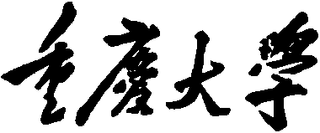


Personal Learning Portfolio

Course： English Academic Writing Teacher： Zhang Mei
Class： 001 Major： CS
Name： Student Number：
Class Time： 2024.02-2024.06
Grade：

Self | Teaching Assistant | Teacher
9

Comments：

Teacher (Signature)
Contents

Starting to Learn English Academic Writing
- My learning
- In class

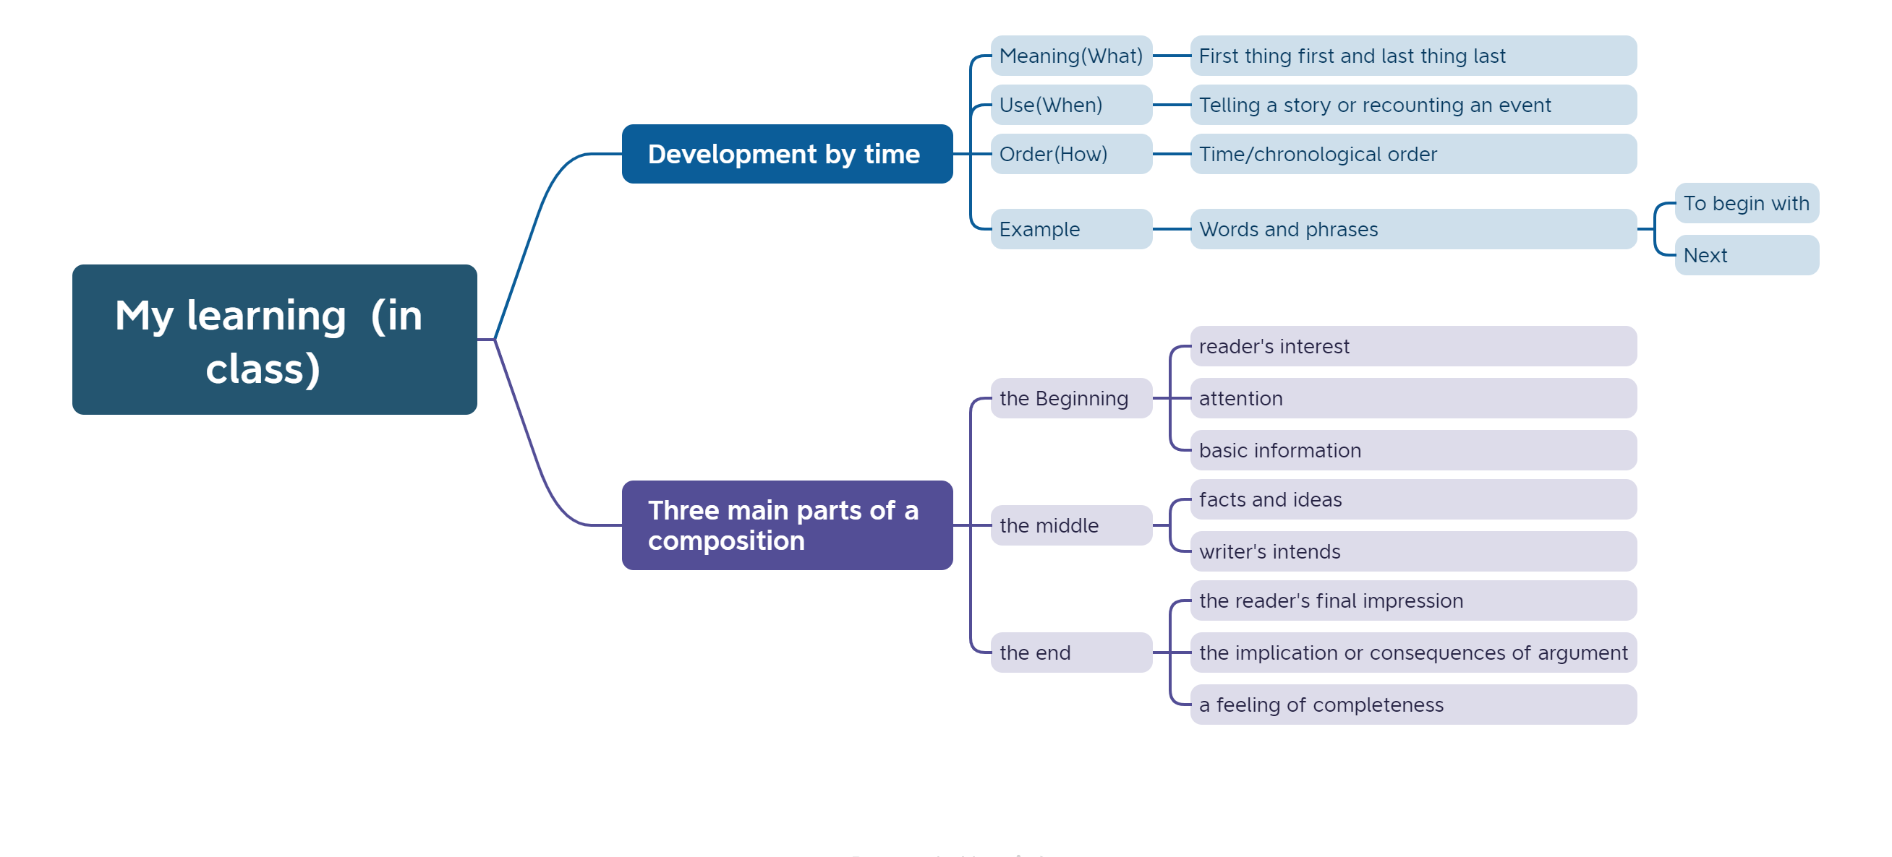
- Out of Class
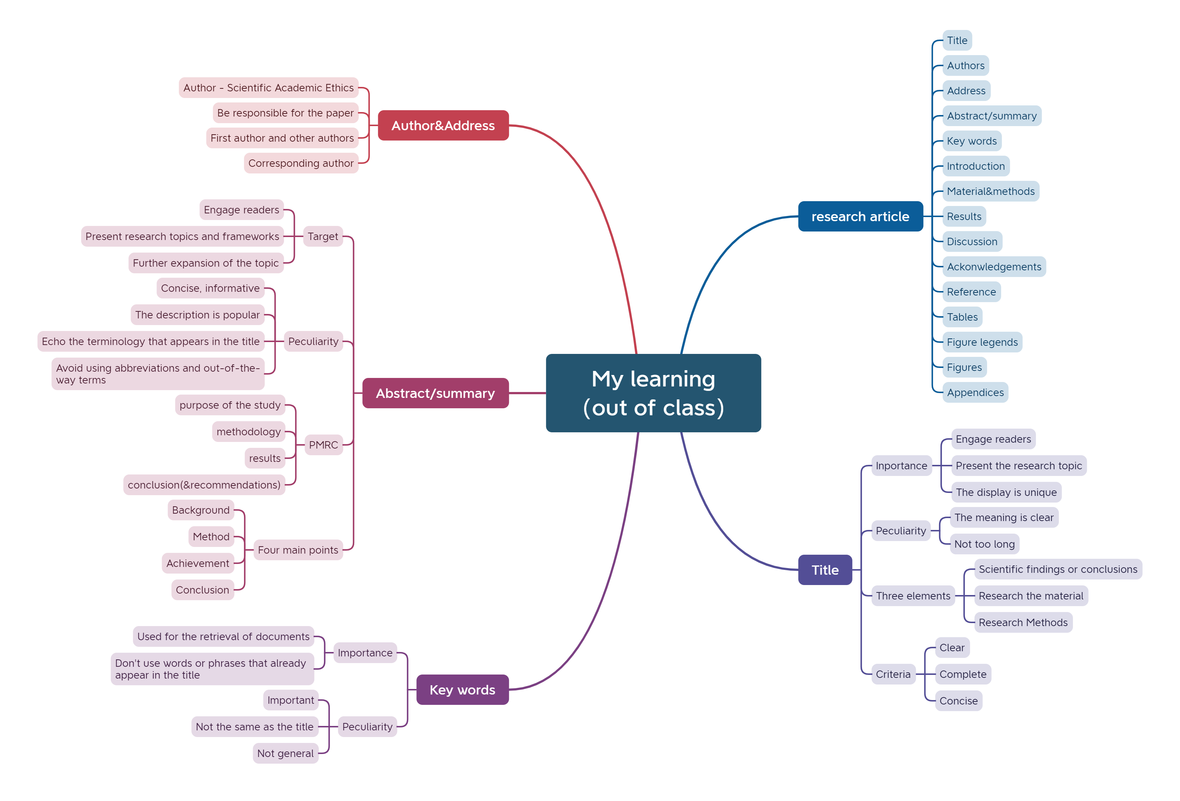
- Learning outcomes
1）In class
1) When I make a PPT next time, I want to pay attention to highlighting the theme and the background color should not be too cluttered.
2) When I narrate chronologically, I need to pay attention to the clarity of the structure and the rigor of the logic.
3) When I write an essay the next time, I will divide it into three parts: the beginning, the middle, and the end.
2）Out of Class
1) When writing future papers, ensure the first paragraph effectively introduces background information and captivates the reader's interest.
2) When structuring the body paragraphs, arrange them logically according to the nature of the subject or the type of paper being written.
3) When writing an abstract, it is necessary to pay attention to the four elements of research background, research methodology, main results, and conclusions.
4)Try not to duplicate the keywords of the paper with the title.
- My behavior and attitude
1）Out of Class
1.1 Autonomous learning (Online + Offline)
1.1.1 Online (CET-6 online course)
1.1.2 Offline (memorize vocabulary and listen to CET-6 listening exercises)
1.2 Homework
I completed my English assignment promptly with a diligent and meticulous attitude, ensuring it was not procrastinated until the deadline.
1.3 Cooperative learning
2）In Class
2.1 Individual performance (Take notes promptly and attentively focus during class).
2.2 Cooperation (Actively participate in classroom discussions)
4．Improvement
1）Out of Class
Through the study of MOOCs, I understood the structure of the preface of the paper : title, Authors, abstract, key words, and grasped the points that need to be paid attention to when writing them
2）In Class
In this class, each of the five groups presented their assignments, which helped me a lot in writing my thesis and my presentation.

